**Geometric Fighter Proposal**

**Game Design Final Project**

|  |  |
| --- | --- |
| **Professor:** | Aaron |
| **Couse:** | COSC 3026 |
| **Student Name:** | Hang Yin |
| **Student Number:** | 301489 |
| **Date:** | September 21, 2015 |

# Introduction

Geometric Fighter is a vertical scroller shooting game which is usually called space shooting game. This game is 2D shooting game which progressed by Construct 2[1]. Geometric Fighter is different from similar type of game. It mix with other games’ advantages and new elements. That is makes this game unique. Geometric Fighter has three difficulty level (easy, normal and hardcore). It keeps simple style, which is easy to understand. The picture below shows the welcome screen.

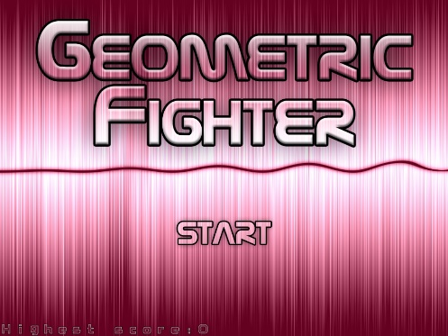

Not only that much space shooting games are ran by PC, but also rare in the mobile devices. This type of game will bring gamers interest.

# Players

In the game, player/players can choose three aircraft. They have their own feature. The first one is scattering style. It is used for decrease the enemy number. It also carries bombs which can provide temporary protection. The second one is defense style. This aircraft weapon power is the weakest, but the ability of survival is strong. This aircraft’s bomb provides regenerating health and protection shield. The third one is focused on attack enemies. It has the highest attack power on single point, and it is good for the boss battle. The bombs carried by this aircraft attack enemies on a straight.



Player will see four property value on GUI (Graphical User Interface). The Geometric Fighter is use HP (health) system to demonstrate how much health player has. Different bullet makes different damage. It shows what enemies are week, what enemies are strong. In power system, player’s attack will be change to point model. This Idea is come from Touhou Project[2]. The more points it get will power the bullet of the aircraft. However, every 100 points will change to stronger type of the shooting bullet. The attack speed system is in game, which provide the increasing shooting speed. Finally, Geometric Fighter has bomb system. It is like other space shooting game (e.g. Raiden[3], Salamander[4]).

# Enemies

There are 12 shapes of enemies. Each shape has at least one AI. They make more than 20 type of enemies. Some AI is week, and some is smarter than other game. They make more challenge in the game.



In the game, there are 6 bosses to be challenged in 6 levels. Each boss has at less 5 different shooting type. There is a mark on GUI in boss battle. The mark will show where boss is, and it make player focus to avoid bullets. Slow movement system make player easier avoid bullets. When player finished the normal mode, they may challenge the boss rush mode. This idea come from a RPG online game called Dragon Nest[5] Player will challenge random boss in this mode.

In total, the enemies make different combos. In hardcore mode, Geometric Fighter become to a barrage game same as Touhou Project. It give a challenge to professional players, and make a fantasy graph by bullets in the game.

# Bibliography

|  |  |  |  |
| --- | --- | --- | --- |
| Series | Name | Platform | Release |
| Touhou Project | Highly Responsive to Prayers | PC-98 predecessor | 1996 |
| Touhou Project | Lotus Land Story | PC-98 predecessor | 1998 |
| Touhou Project | The Embodiment of Scarlet Devil | Windows | 2002 |
| Touhou Project | Perfect Cherry Blossom | Windows | 2003 |
| Touhou Project | Imperishable Night | Windows | 2004 |
| Touhou Project | Phantasmagoria of Flower View | Windows | 2005 |
| Touhou Project | Shoot the Bullet | Windows | 2005 |
| Touhou Project | Subterranean Animism | Windows | 2008 |
| Touhou Project | Undefined Fantastic Object | Windows | 2009 |
| Salamander | Salamander 2 | Sega Saturn | 1996 |
| Raiden | Raiden III | Windows | 2005 |
| Raiden | Raiden IV | Windows | 2007 |
| Resogun | Resogun | PS4 | 2013 |

1. Scirra, Construct2[CP/DK], https://www.scirra.com/construct2, 2012
2. Team Shanghai Alice, Touhou Project[CP/DK], https://en.wikipedia.org/wiki/Touhou_Project
3. Seibu Kaihatsu, Raiden[CP/DK], https://en.wikipedia.org/wiki/Raiden_(video_game), 1990
4. Konami, SPS, Salamander[CP/DK], https://en.wikipedia.org/wiki/Salamander_(video_game), 1986
5. Eyedentity Games, Dragon Nest[CP/DK], http://dragonnest.nexon.net/, 2010